Guia 29: Notificaciones

Notificaciones Internas

1. Crear un proyecto base.
2. Agregar un boton y asociar el metodo notificacionInterna.
3. Agregar el siguiente codigo al metodo creado.

**package** mobile.calyr.com.notificaciones;

**import** android.app.NotificationManager;

**import** android.app.PendingIntent;

**import** android.content.Context;

**import** android.content.Intent;

**import** android.media.RingtoneManager;

**import** android.net.Uri;

**import** android.support.v4.app.NotificationCompat;

**import** android.support.v4.app.NotificationManagerCompat;

**import** android.support.v7.app.AppCompatActivity;

**import** android.os.Bundle;

**import** android.view.View;

**public class** MainActivity **extends** AppCompatActivity {

@Override

**protected void** onCreate(Bundle savedInstanceState) {

**super**.onCreate(savedInstanceState);

setContentView(R.layout.***activity_main***);

}

**public void** notificacionInterna(View view) {

Intent i = **new** Intent(**this**, MainActivity.**class**);

PendingIntent pendingIntent = PendingIntent.*getActivity*(**this**, 0, i, PendingIntent.***FLAG_ONE_SHOT***);

Uri sonido = RingtoneManager.*getDefaultUri*(RingtoneManager.***TYPE_NOTIFICATION***);

NotificationCompat.Builder notification = **new** NotificationCompat.Builder(**this**)

.setSmallIcon(R.drawable.***ic_stat_name***)

.setContentTitle(**"Notificación"**)

.setContentText(**"Notificaciones Internas"**)

.setSound(sonido)

.setContentIntent(pendingIntent)

.setAutoCancel(**true**)

;

NotificationManager notificationManager = (NotificationManager) getSystemService(Context.***NOTIFICATION_SERVICE***);

notificationManager.notify(0, notification.build());

}

}

Firebase

1. Ingresar a <https://firebase.google.com>

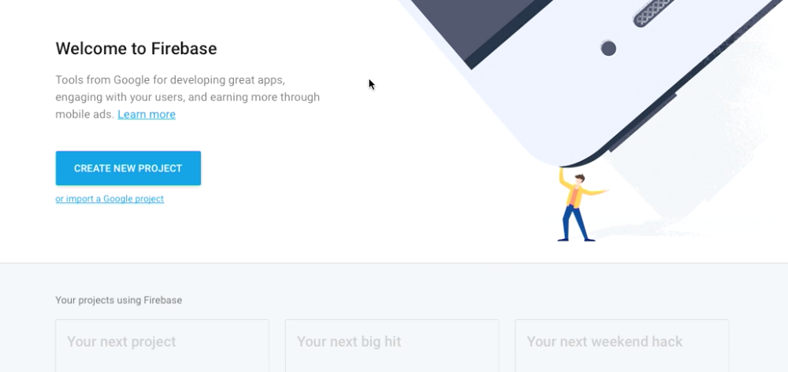

2. Crear un proyecto con el asistente de firebase en Android Studio.

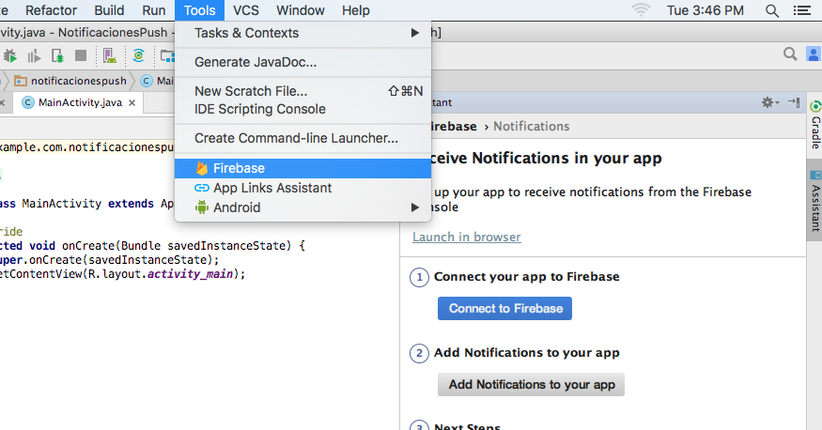

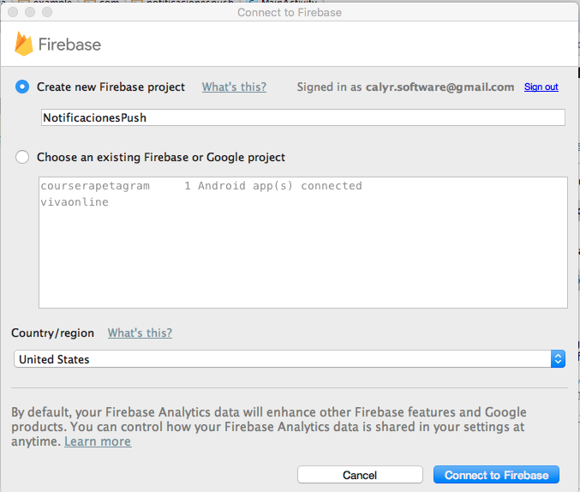

3. Modificar el archivo Gradle App

apply **plugin**: **'com.android.application'**

android {

compileSdkVersion 26

buildToolsVersion **"26.0.1"**

defaultConfig {

applicationId **"mobile.calyr.com.notificaciones"**

minSdkVersion 19

targetSdkVersion 26

versionCode 1

versionName **"1.0"**

testInstrumentationRunner **"android.support.test.runner.AndroidJUnitRunner"**

}

buildTypes {

release {

minifyEnabled **false**

proguardFiles getDefaultProguardFile(**'proguard-android.txt'**), **'proguard-rules.pro'**

}

}

}

dependencies {

compile fileTree(**dir**: **'libs'**, **include**: [**'*.jar'**])

androidTestCompile(**'com.android.support.test.espresso:espresso-core:2.2.2'**, {

exclude **group**: **'com.android.support'**, **module**: **'support-annotations'**

})

compile **'com.android.support:appcompat-v7:26.+'**

compile **'com.android.support.constraint:constraint-layout:1.0.2'**

compile **'com.google.firebase:firebase-core:10.0.1'**

compile **'com.google.firebase:firebase-messaging:10.0.1'**

testCompile **'junit:junit:4.12'**

}

apply **plugin**: **'com.google.gms.google-services'**

4. Crear las clases MyFirebaseMessagingService y MyFirebaseInstanceIDService

**import** android.util.Log;

**import** com.google.firebase.messaging.FirebaseMessagingService;

**import** com.google.firebase.messaging.RemoteMessage;

*/\*\**

*\* Created by robertocarloscallisayamamani on 10/10/17.*

*\*/*

**public class** MyFirebaseMessagingService **extends** FirebaseMessagingService {

**private static final** String ***TAG*** = **"MyFirebaseMsgService"**;

@Override

**public void** onMessageReceived(RemoteMessage remoteMessage) {

**super**.onMessageReceived(remoteMessage);

Log.*d*(***TAG***, **"From: "** + remoteMessage.getFrom());

*// Check if message contains a notification payload.*

**if** (remoteMessage.getNotification() != **null**) {

Log.*d*(***TAG***, **"Message Notification Body: "** + remoteMessage.getNotification().getBody());

}

}

}

**import** com.google.firebase.messaging.FirebaseMessagingService;

*/\*\**

*\* Created by robertocarloscallisaya on 10/10/17.*

*\*/*

**public class** MyFirebaseInstanceIDService **extends** FirebaseMessagingService {

}

5. Probar el envío de notificaciones push por medio de la consola de Firebase.

